**3 Waters Processes and ‘How to’ Guidance**

*This document is aiming to identify and document the key 3W asset processes.*

Contents

1. Finding Assets 2
2. Export lists of assets 3
3. How does QLDC get new 3waters assets? 3
4. New Assets for Facilities / above ground 4
5. New Assets for network/distributed/ below ground. 4
6. Vested Asset Consent Number Referencing - GIS 5
7. Capitalisation of CAPEX projects 5
8. **Capitalise WIP** 5
9. Renewals of Facilities / above ground assets – ***(Promapp pending to be written)*** 8
10. Renewals-network assets. 8
11. Monthly GIS – TechOne Synchronization EAM Update 9
12. Disposing Assets that are in operational system, but need to come off Asset Book 10
13. Linear assets that are existing, that have sections of the existing asset removed, some parts abandoned and some parts existing spatially modified. 10
14. Valuations 10
15. Managing TechOne Type codes 10
16. Managing TechOne Type codes…………………………………………………………………………………………………………………10

**Introduction to 3 Waters Asset searching and management**

# Finding Assets

1. **Opening T1 CIA Enterprise Asset Management /Asset Register** 
   * Go to CIA / All Roles / Enterprise Asset management (EAM) / Assets

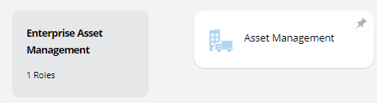

1. **Find assets**
   * Go to CIA / Enterprise Asset management (EAM) / Assets
   * The best way to find the asset is to get the GIS COMPKEY (which is ‘other Identification’ in T1).
   * Open the Criteria Builder (dropdown on search bar)

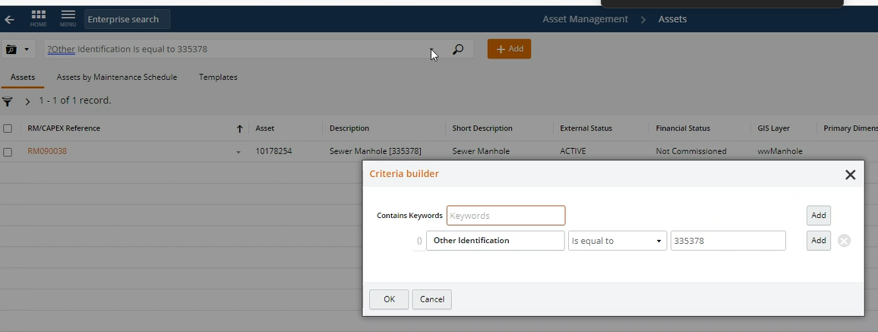

* + Also the RM/CAPEX Reference is

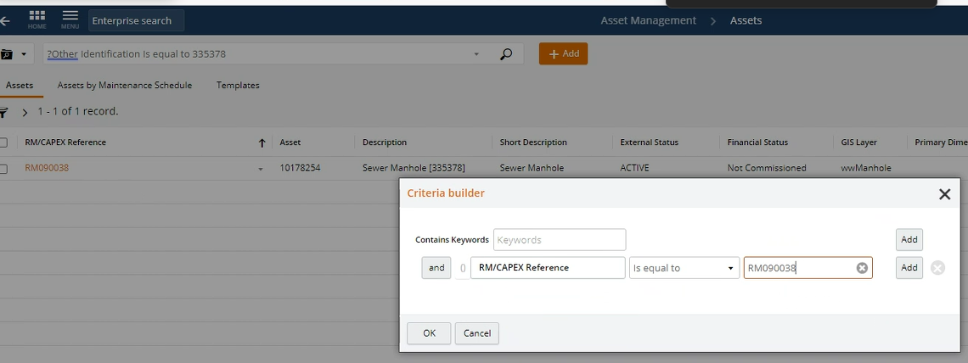

1. **Search asset list** (ensure has specific fields)

There are 3 ways to get lists of assets

i) use the exact Asset ID

ii) for facilities (above ground) you need the exact Parent Asset ID, to get this you need the extract GIS COMPKEY. (find in GIS) [insert link]. The Parent Asset is the Polygon in GIS, the children are only in TechOne.

* + using the Asset ID eg ‘1014830 you can get a list of all the children asset ’

iiI) for Underground assets the easiest – know the name of the project, eg ‘description’, or the ‘RM/CAPEX reference’ -eg 20/21 Hawea WWTP Upgrade -

**NB for QLDC own referencing we use the RM/CAPEX reference**

**-** PMO use Contract number – project level  eg CAPEX 000434

- Renewals use the Work Orders names eg 20/21 Replace controller 2 mile water

**Note**: as for Facilities the Asset Officer will need to provided with a GIS snap map of the exact location of the renewed/replaced assets and their GIS COMP KEY

-Vested Assets –Use the consent number eg RM12345. SD12345, SS12345

[**NOTE**](https://au.promapp.com/qldc/Process/46ff8a1b-020c-4f10-959b-21cd3526311c?force=False)

* To filter assets to just a single facility location:
  + Use the filters on the left of TechOne asset screen to filter to Treatment Processing and Bulk Storage asset type. This is the only way for the Parent Asset Number field to able to be added to the table view
  + Use the Search bar to search for the GIS name of the facility in the Details field (e.g. ?Details contains WRWR-WESTERN)
  + Note the asset number of the parent asset
  + Filter on the parent asset number of the parent facility of interest (e.g. ?Parent Asset Number is equal to XXXXXX)
* Some fields do not show up unless you are at the correct hierarchical level in TechOne
  + For example, pipe material and diameter will not appear unless you are filtered down to the Mains/Pipes level of ASSET TYPE

# Export lists of assets

* + 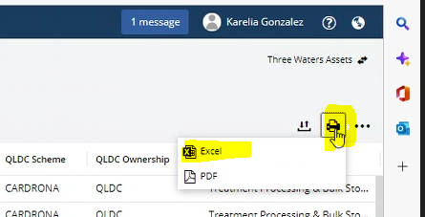Go to the printer button and select excel

# How does QLDC get new 3waters assets?

**Promapps – 3 waters lifecycle:**

[**Three Waters Asset Lifecycle (L1.2) | Nintex Promapp®**](https://au.promapp.com/qldc/Process/d09beddd-9321-4477-91df-06a2f7c0e5da?force=True)

[**Create Three Waters Asset | Nintex Promapp®**](https://au.promapp.com/qldc/Process/e5b640dd-cb4a-4d46-8a4b-e5835a34c02e)

**Capital works:**

[**Process CAPEX Project | Nintex Promapp®**](https://au.promapp.com/qldc/Process/762371ae-d9d4-41a5-a335-cab7130c00c4?force=False) / [**Collect 3W facility asset information | Nintex Promapp®**](https://au.promapp.com/qldc/Process?processUniqueId=c77416fe-cad8-4146-83a8-fc68498013e9)

[***Load facility assets into TechOne Asset Register | Nintex Promapp®***](https://au.promapp.com/qldc/Process/17d9eb1e-eb86-4311-9280-3ae1a6c25b2f?force=False) ***(Needs to be reviewed and rewritten)***

**Vested Assets -**

[**Create Three Waters Asset - Distributed Assets | Nintex Promapp®**](https://au.promapp.com/qldc/Process/0601f6ab-f52f-4a3a-9c90-a333094ba36f?force=False)

**Maintenance Contractor - (direct into GIS)**

# New Assets for Facilities / above ground

* 1. Usually facilities are from Capex projects (occasionally also vested e.g. Hanley farm).
  2. The first step is to get a polygon in GIS
  3. The Project Manger PMO/External consultant/Contractor must email [threewaters@qldc.govt.nz](mailto:threewaters@qldc.govt.nz) and CC [Karelia.gonzalez@qldc.govt.nz](mailto:Karelia.gonzalez@qldc.govt.nz) to ask for this to be created – a snip or plan must be provided with location and extent details(Name: e.g. WWTP-Shotover Bridge, RM/CAPEX Ref: e.g. C-XX-XXX, install date, ownership, etc.) – as-builts etc..
  4. The Polygon in GIS of the facility needs to be created in GIS (by Steve Boswell).
  5. Steve notified Karelia and the PMO that the polygon is created. Steve provides the COMPKEY (autogenerated code for the unique site) to the project managers
  6. The PMO (their contractor) completes the facilities spreadsheet/asset register.
     + They must refer to the Asset Identification Policy to understand the coding of asset names/numbers
  7. The PM provides the COMPKEY reference/polygon information to the Asset Officer (Karelia) along with the Asset Register spreadsheet. These must match exactly.
  8. The polygon information is loaded into T1 through the monthly EAM GIS Synchronisation Process.
  9. Karelia must then update the facilities assets into TechOne. She will search for the new Facility record (the COMPKEY of the polygon). This has its own Techone Asset reference id, and it becomes the ‘Parent Asset Number’ / the ‘Site Code’ for all the other asset components to be linked to.
  10. The Asset Officer will prepare the .csv TechOne file load with the assets list previously provided by the PM.
  11. The ‘FacilityAdditions_TechOneLoad_Template.xlsx’ file allows for copying an asset register provided by a PM/contractor and have it converted to a TechOne file load. This is a little finicky and requires some work to get the final file in order before loading to TechOne through ‘My Imports’.

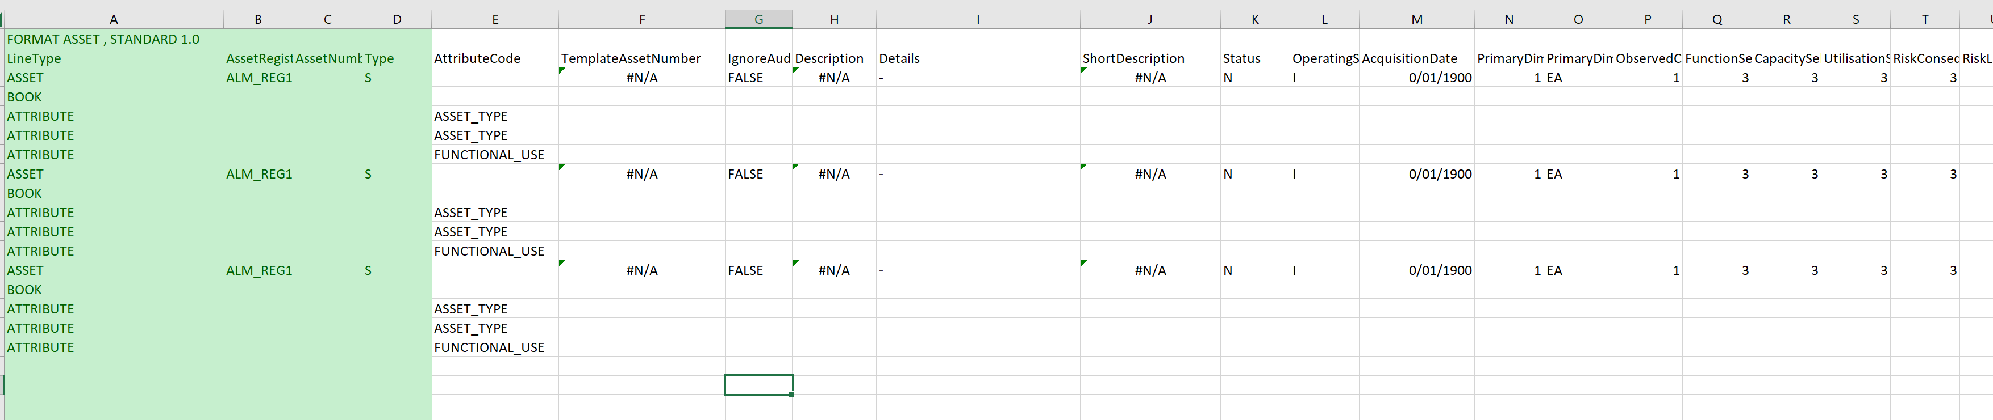

[***Load facility assets into TechOne Asset Register | Nintex Promapp®***](https://au.promapp.com/qldc/Process/17d9eb1e-eb86-4311-9280-3ae1a6c25b2f?force=False) ***(Needs to be reviewed and maybe rewritten).***

# New Assets for network/distributed/ below ground.

1. Capex project / Land development / subdivision is created.
2. Notification to the [threewaters@qldc.govt.nz](mailto:threewaters@qldc.govt.nz) and CC [Karelia.gonzalez@qldc.govt.nz](mailto:Karelia.gonzalez@qldc.govt.nz).from either
   1. Project Manger that a project is near completion or
   2. Planning & Development Subdivision Team that a subdivision is going to be vested (224c is imminent) and requesting that the GIS needs to be loaded.
   3. Sometimes notifications come direct from surveyors
3. Data is submitted via the GIS Portal. This is reviewed by the Asset Engineers/ Steve Boswell, once QLDC is happy that the data meets specification, the data will be loaded into the QLDC live GIS data.
4. P&I or Steve will notify the Project manager, or P&D that we are happy with the data. 224c or practical completion will not be issued until the data is accepted by the Assets team.
5. P&I or Steve will need to timesheet their time against
   1. the specific physical works capital project
   2. The Subdivision consent number
   3. For generic works the relevant years projects for asset management improvements – split evenly against Stormwater / waste water / water supply
6. The data must then be synchronised from GIS into TechOne. There is a Monthly ETL process for this – see **Monthly GIS – TechOne Synchronisation EAM Update**

Promapp: [**Create Three Waters Asset - Distributed Assets | Nintex Promapp®**](https://au.promapp.com/qldc/Process/0601f6ab-f52f-4a3a-9c90-a333094ba36f)

# Vested Asset Consent Number Referencing - GIS

The new assets within the webmap should be labelled with the correct *RM/CAPEX Ref* for the consent or stage in question (i.e. the subdivision or land use  ‘Child App’ file containing the ‘224c application’ or ‘Signing & Sealing application’ under which the assets were vested).

* Child App’ code for P&I/Consultants to invoice to (e.g. ***SD190505.04***)
* Consent No. and Stage No for the ‘*RM/CAPEX REF*’ field, where applicable (e.g. ***RM190505, Stage 15D***)

**Please Note:**

* The Subdivision ‘Child App’ Code is not usually known or allocated until post-lodgement.  This means that, when the webmap is submitted,  the new assets will usually be labelled by the consultant with the ‘Parent App’ consent/RM reference only.

* For staged subdivisions/developments, Steve has agreed to do a bulk update of new assets with the correct RM/CAPEX ref details for the specific consent and/or stage of subdivision.  We also want to include the related ‘SS’ or ‘SD’ file reference in brackets to make it easy for people to locate the correct ‘Child App’ file containing the 224c application (or signing & sealing application) info and vesting info in future.  The ‘Child App’ is where the related LT plans, easements, 224c issue dates/defects period commencement dates etc can be located.

# Capitalisation of CAPEX projects

Promapps that can be checked:

[**Minimode | Nintex Promapp®**](https://au.promapp.com/qldc/Process/Minimode/Permalink/Cm992CD7X0dW0ekvz0DW5B)

[**Set Cost Allocations to Assets | Nintex Promapp®**](https://au.promapp.com/qldc/Process/46ff8a1b-020c-4f10-959b-21cd3526311c?force=False)

# **Capitalise WIP**

**https://au.promapp.com/qldc/Process/Minimode/Permalink/HWbF8rEsRPU7RVN1BacXxn**

*Explain capitalisation – and the % cost distribution.*

1. All asset data must have values associated with them, so the assets can be capitalized. All asset data should have been provided by the project managers (either facility of distributed assets)
2. Asset Officer extracts a list from TechOne of all the new assets for a specific project. Usually by the project name, reference or parent number.
   1. List contains certain fields to help the PM’s identify the assets. The key field is the TechOne asset number, also includes short description, long descriptions, COMPKEY.
   2. For facilities the Replacement Cost field should have been populated vis the facilities register spreadsheet
   3. For network assets the value will be blank and needs to be populated with the Replacement Value field.

assets are coming to fianance to be capitalised that shouldn’t be.

These are generally nodes and inlets and something else that I can’t remember

Although susan has have blocked the system from capitalising these assets, and asked for dashboards, it still causes lots of back and forth and time to sort out. When I do eventually hand over my Asset Processing tasks, I can’t expect the new person to be a 3W expert, so less will be caught and more nuanced stuff will get through

My new thinking is to allow these assets to be capitalised so that we can be get a pace on and tell WSP so that they we can resolve it each time there is a valuation. As you can’t revalue something to $0 (that’s a disposal, which is another process), they would need to be valued at 0.01.

I can’t think of another solution that has the outcome of reducing time back and forth between Karelia / Project Data Analysts, Jeremy and myself

This year, work orders are coming to me again with costs being capitalised to operational assets (nodes). Luckily I managed to intercept the one today, but if it carries on, it can’t be guaranteed that with my new role that every single 3W asset is going to be checked to this level of detail. The one today would have meant a 40K mistake, so, you can imagine that could accumulate if it carries on

The **good news** is that there is a way to prevent this from happening again :

* Update the node asset templates so nodes assets are NOT available for capitalisation  
  *This means that the system simply will not process costs against them (this is my preference and recommendation)*
* Update existing Node assets to NOT be available for capitalisation

I have set this up as above in the [test system](https://qldc-test.t1cloud.com/T1Default/CiAnywhere/Web/QLDC-TEST/Workplace) and the screenshot below shows where the setting lives in the asset book in case you were wondering

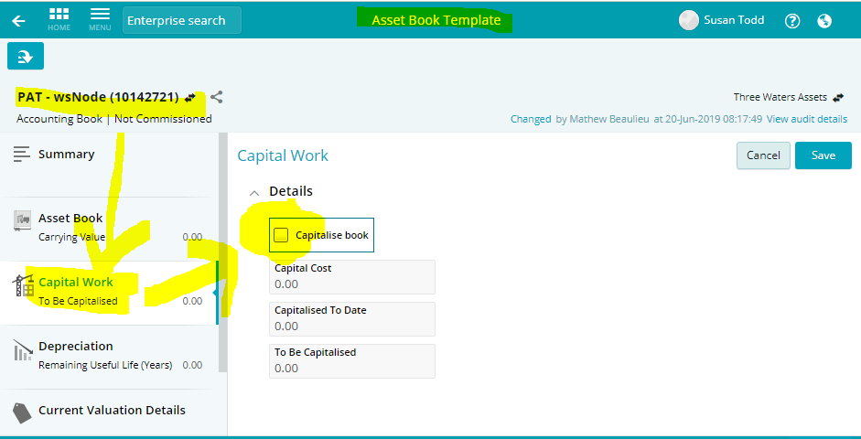

P**rojects that involve either facilities or facilities and reticulation?**

a. The assets need to be created within TechOne (from GIS for reticulated and from spreadsheet for facilities).  
b. The Asset Officer then exports an asset list from Techone to a spreadsheet (this ensures that the new TechOne asset IDs are captured) with the facilities on one tab and the distributed assets on the other.

c. The PM then allocates the % of the total project cost to each asset, based on contract schedules and unit rates for pipework.

1. 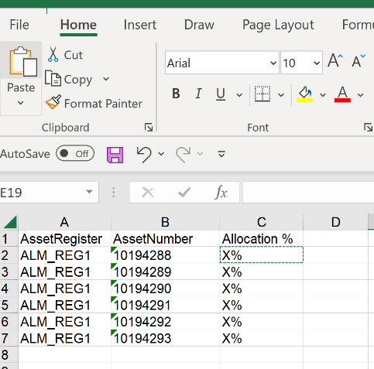Project manager ensures that costs are apportioned (broken down to %) against assets in T1-Ci-CES, and all the assets’ costs are allocated against each of the Work Orders linked to the Project. They need to create a CSV file with the assets list and their values that will be dragged into the WO (T1-Ci).

**Promapp:** [**Set Cost Allocations to Assets | Nintex Promapp®**](https://au.promapp.com/qldc/Process/46ff8a1b-020c-4f10-959b-21cd3526311c?force=False)

1. Drag assets cost to T1-WorkOrders. Before work order transactions are capitalised, finance advisory will discuss with the project manager an appropriate cost allocation % across the various financial asset types (see the example below).

Processing Capital WIP (Works in Process)

**Additional Notes from Financial Department:**

*Reading the Capital WIP 3 W Renewals report (WorkOrders financial statuts report) (may 2023)*

Info Finance Requires for each workorder to enable the capitalisation process:

On receipt of the Capital WIP spreadsheets – please go through and complete the fields with the info below.

**Capitalisation Date** – Month end date when work was completed (if in the past) or estimated to be completed (if in the future).  This is really handy to keep updated because if its not going to be completed this financial year, we can filter out from our 30/6/2023 year end analysis so know which workorders to focus on.

**Capitalisation Notes** – Useful comments/information notes that we can load into TechOne that tells us where the workorder is at in our capitalisation process.

**If the Capitalisation/Completion Date is in the past, suggested useful example comments are:**

Completed Dec 22. Awaiting Asbuilt info from Veolia

Completed Dec 22: Commitments to be closed. Awaiting asset/asbuilt info

Completed Dec 22. Asbuilts received. Awaiting GIS mapping.

Completed Dec 22. Asset Allocation complete 19/5/23 (with your initials) when you are happy that assets have been loaded onto the workorder.

*Note any comments that say estimated completion with a date in the past would need to be updated*

**If the Capitalisation/Completion Date is in the future, suggested useful example comments are:**

Est completion Oct 23

Est completion Mar 24. Design only 22/23. Constr 23/24

Est completion 24/25. Cap with project no.00XXXX

**If the Capitalisation/Completion Date is blank, possible comments could be:**

Transfer to opex

Transfer actuals to CP workorder

**Capitalisation Status** – This is great for easily filtering data and understanding what stages workorders are at:

CAPREADY / Ready to Capitalise - You can ignore anything that are tagged CAPREADY. Finance is the only one that should tag as CAPREADY when we have reviewed that the assets have been tagged and configured correctly with the Scheme and GL, the workorder will be inactive and the capitalisation process with follow to remove from capital WIP.

WIP / Work in Progress - At the year end June 30/06/2023 only workorders where work is continuing into 23/24 should be tagged as WIP. By filtering on the capitalisation date, if up to date Finance can easily pickup the workorders not due to be completed until future years and tag as WIP.

ASSREV / Asset review - Status used to show where we are awaiting asset info

OPREV / Opex review - Where costs should be moved to opex

COMMREV / Commitment Review – Handy to tag when we think everything is completed but not sure if remaining PO’s need to be deleted or if awaiting another final invoice or two. The comments filed can cover off this instead but an option still to use.

ASSTAG / Assets Tagged – When assets have been loaded onto the workorder with the correct split.

Finance is happy to update all of the above if we get relevant commentary for the capitalisation notes/comments field. Although ASSTAG can be handy for the PM or admin person who has updated the assets onto the workorder with % splits to update in TechOne, then email to finance stating in the ‘Capitalisation Notes’ comments field “Asset Allocation complete with the date and your initials”.

#### Sharing the Contractor/Surveyor web map link with an external reviewer:

1. **(Contractor)** or Contractor’s surveyor sends the link to a CAPEX as-built web map to Steve at [threewatersdata@qldc.govt.nz](mailto:threewatersdata@qldc.govt.nz) (copying in the Project Manager).
2. (**Project Manager**) sends an email to the Geo Spatial team at [gis@qldc.govt.nz](mailto:gis@qldc.govt.nz), asking for the web map link to be shared with the CAPEX As-builts group, and request the reviewer account password to be reset (copying in Steve Boswell [threewatersdata@qldc.govt.nz](mailto:threewatersdata@qldc.govt.nz)).
3. (**Geospatial Team**) to respond with the new password once that’s done.
4. (**Project Manager**) to email the link to the map, the username (CAPEX.Asbuilt_Ext), and the password to the external reviewer
5. (**Project Manager)** to email Steve Boswell [threewatersdata@qldc.govt.nz](mailto:threewatersdata@qldc.govt.nz) to approve for upload once the data has been reviewed and found correct

# Renewals of Facilities / above ground assets – ***(Promapp pending to be written)***

1. Project Managers have to send an email to the asset officer (Karelia Gonzalez) with all the details about the job and the assets included on it:
   1. Name of the project
   2. GIS snipping of the exact location of the assets.
   3. Asset Register form with all the data about the facility: Name (Fernhill Water Reservoir), job details, the asset list and their full information.
   4. GIS compkey list of the Facility and the assets that will be replaced/dismissed.
2. Asset officer creates the .csv T1 template with the new assets list and uploads it manually into T1-CIA. Promapp: [***Load facility assets into TechOne Asset Register | Nintex Promapp®***](https://au.promapp.com/qldc/Process/17d9eb1e-eb86-4311-9280-3ae1a6c25b2f?force=False) ***(Needs to be reviewed and maybe rewritten).***
3. Asset officer sent back to the Project Managers the extract asset list from T1 that will need to be broken down proportionally and allocated against each Work Order in CI-CES to complete the capitalization process.

# Renewals-network assets.

1. Internal PM/Contract Manager request assets to be loaded in GIS. Provide site compkey below ground assets.
2. Steve B finds the existing assets in GIS and tags them with the appropriate identification job reference.
3. Steve makes the changes. These changes will be updated into T1 through the monthly synchronization process.
4. Asset Officer emails back to the PM the assets list with their T1 asset number and description.
5. Asset officer sent back to the Project Managers the extract asset list from T1 that will need to be broken down proportionally and allocated against each Work Order in CI-CES to complete the capitalization process.

# Monthly GIS – TechOne Synchronization EAM Update

1. The GIS polygon information will be loaded into T1 as part of the EAM process that occurs monthly.

**Note:** If this were the necessary, it can be done for an individual asset by modifying the ETL script manually.

1. This is a shortcut to a location on O:/ that stores the FME tool that runs the GIS to TechOne synchronization (Enterprise_GISChanges_v2.fmw). It is a tool that looks for changes in GIS and produces a CSV in TechOne import format of those changes.
2. See [**Create Three Waters Asset - Distributed Assets | Nintex Promapp®**](https://au.promapp.com/qldc/Process/0601f6ab-f52f-4a3a-9c90-a333094ba36f)

[**NOTE**](https://au.promapp.com/qldc/Process/46ff8a1b-020c-4f10-959b-21cd3526311c?force=False)

* An ETL process runs daily to produce a list of Asset Numbers already in TechOne. This allows the synchronization tool to update assets that already exist in the system and create new ones for any that do not exist.
* The ETL that does this is called "GISID_ASSETNUM_ALM_REG1”
  1. These are the following steps to run the tool and update TechOne
     1. Login to the FME Data Interop license from within ArcPro (might need to restart ArcPro after logging in)
     2. Username: Data.Interop_QLDC
     3. Pword: W5XqX2&B6y
     4. Run the tool so that an updated CSV (FinalTechOneFormat.csv) is created in the ‘TechOneFormats’ folder
     5. Create a new folder with the date of the day the tool was run and save a copy of the FinalTechOneFormat.csv file in the new folder.
  2. Do QA/QC on the file, it will take some time to get used to the issues that pop up but the main columns that run into issues are:
* AssetAttributeSelectionType4
* AssetAttributeSelectionType1
* AssetAttributeSelectionType2
* AssetAttributeSelectionType3

**DO NOT RE-SORT** this file. The TechOne format is very picky and changing the order of the rows will really screw things up. It’s OK to filter to find bad rows but do not re-sort it.

* Add the single line in TechOneLoad_HeaderFormatAsset.csv to the top row of the QA/QC’d CSV.
* You will need to Save As and overwrite the existing CSV file as just saving will try to save it as Unicode text (not readable by TechOne)
* Drag and drop the completed CSV into the ‘My Imports’ page of TEchOne
* Fix any errors that pop up.
* If too many show up (rule of thumb is >30 errors), it is worth going back to GIS and updating the issues there and re-running the tool.
* **TO RERUN THE TOOL**
  + Open the Rundate.txt file in the GIS_Synchronisation folder. Change the date to the date of the previous run date. I usually just change it back to the date and 00:00:00 to be safe.

# Disposing Assets that are in operational system, but need to come off Asset Book

* Provide an email (Susan to provide a template of what she requires) stating that x assets need to be taken off the asset book, along with the value. Usually assets that are owned by ORC or private etc…

# Works that amend existing assets

# Linear assets that are existing, that have sections of the existing asset removed, some parts abandoned and some parts existing spatially modified.

What would the impacts be on the financial systems to decommission/remove any asset that is touched by these asbuilts and then load ALL the assets we get from these asbuilts into GIS (including the removed and abandoned assets so we have a record). I know this would change the COMPKEY of these assets. Would this make a nightmare in Tech One Karelia?

An example of the complexity is to imagine a 100m long existing pipe is the ground. We now abandon the first 20m of the pipe, remove the next 20m, keep the next 20, then abandon the next 20m, then remove the last 20.... We have no method to deal with this as we now have 5 pipes where we had one and they all need COMPKEYS and different statuses.

# 3 Waters assets Valuations

# **General Valuation information**

*Link to Infrastructure Valuation Policy*

[Document Properties (t1cloud.com)](https://qldc.t1cloud.com/T1Default/CiAnywhere/Web/QLDC/ECMCore/DocumentProperties?f=%24EMC.DOC.PROP.MNT&h=yPCGaqPaTQ&t=1416150B&suite=ECM)

*Promapp*: [Undertake required 3 Waters valuations, Nintex Process Manager (promapp.com)](https://au.promapp.com/qldc/Process/376c2861-e25b-43de-b449-810a6758a5e8?Area=Process)

# **Valuation Process**

1. Database - extract 3 Waters network & Facilities. QLDC extract from TechOne and send them to Valuer (WSP) the 4 data sets required to undertake the valuation (SW, WS, WW & Facilities). The extraction must be done including the data book.



1. Valuation methodology
   1. Attributes to be included:

Financial status: Commissioned

QLDC Ownership: QLDC, Unknown, TBD, Pending.

External Status: Active, TBD, Inactive.

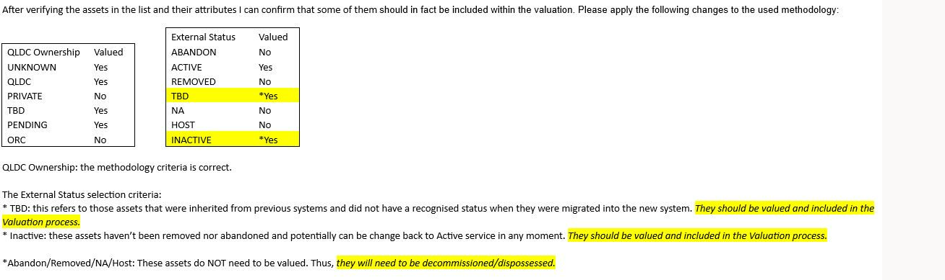

1. QLDC Current Valuer – WSP – Contract: C-21-195.195 – Expire date TBC

**Summary of Current Contract specifications:**

*“… For the 3-waters valuation, we (WSP) would extract all applicable tables from the TechnologyOne*

*asset register at an agreed date that would form the snapshot. We will then produce valuation schedules to work from much like the ‘cut’ methodology outlined above, so that the live database can continue to be used by Council asset managers and their suppliers without interruption. Valuation outputs will be presented in formats suitable for upload into the TechnologyOne asset register should they wish to populate the valuation fields within the live asset register at the end of the valuation cycle”.*

*“Financial Valuation Methodology*

*The valuation will be undertaken in accordance with Public Benefit Entity International Public Sector Accounting Standard 16 Property, Plant and Equipment (PBE IPSAS 16) and appropriate international valuation standards. It will also follow standard local authority valuation and depreciation practices and satisfy Audit NZ requirements.*

*The valuation will be based on an Optimised Depreciated Replacement Cost (ODRC) approach.*

*This process involves five main steps:*

*1. Prepare the list of assets to be valued, breaking into components as required.*

*2. Estimation of the current replacement cost using a modern equivalent asset*

*for each asset and component.*

*3. Adjustment to reflect an optimised asset arrangement, where appropriate*

*4. Estimation of the remaining useful life of each asset and component.*

*5. Calculation of Replacement Cost, Depreciated Replacement Cost and Annual Depreciation.”*

**Timetable set as per contract.**

*Building the Foundation (March 1st – March 28th)*

*· Data Collection and Familiarization – This will involve a desktop study of all relevant*

*information sources (such as previous valuations, asset management plans, maintenance plans, capital expenditure records, asset registers and drawings) and discussions with QLDC personnel.*

*· Valuation Schedules – This will involve creating standard valuation schedule templates,*

*entering asset data downloaded from QLDC’s databases, and developing current valuation parameters such as unit costs, asset lives, recent impairment, additions and deletions etc.*

*· Delivery of the Carrying Value Assessment 15th March.*

*Analysis and Valuation (April 1st - April 14th)*

*Reporting (April 15th – May 31st)*

*· Report Preparation – Full documentation of the asset valuation process and results will be presented in draft format 30th April. The report will then be finalised based on feedback from the peer review meeting and comments from QLDC.*

***IMPORTANT NOTE****: When we brought all of our 3W water assets into TechOne from the previous system, everything had its commission date updated to 01/07/2019. It is unclear why.  
  
When the valuer comes back with depreciation rates based on the actual physical commission date, we can't update them like-for-like in the Asset Book to calculate depreciation going forward. This is because the valuers are working on the actual physical commission date of the asset, and in the Asset Book we are holding the system implementation date as the commission date.  
  
To update our system so that our asset costs and our depreciation costs are calculated correctly, we need to enter the remaining asset life give to us by the valuers into the 'Revised Remaining Useful Life (Years)' field and understand that the 'Revised Depreciation Rate' recalculated by the system is not going to match the valuers' data. Doing it this way ensures that the Depreciation AMOUNT is calculated correctly.  
  
When you enter a Remaining Useful Life into the system, the Revised Useful Life is updated on a calculation that is based on the commission date in the system. Because the commission dates don't reflect the actual physical commission date of the asset, these fields are not going to match the valuers' data.*

*In the past*

*\\sqldcfile01\P&I\3Waters\Asset Management\Reporting\Valuations\Insurance*

# Insurance Schedules – Facilities

Following the insurance schedules

**Timing**

*Confirm dates that Insurance data is required for each policy? Netowrk– Ask Gareth Noble

Facilities Policy renewals is due APRIL

-when in April is insurance policy renewed?

-how much time before renewals do we need to provide data?

Assets to include in insurance schedule - all assets commissioned at date of extract – includes those not valued.

1. Export from TechOne all facilities assets commissioned
2. Apply the last valuation criteria to any assets commissioned since the last valuations
3. The schedule needs to add physical address to schedule from GIS -match using COMPKEY

Regarding the insurance schedules, the files we were sent did not include the calculations of the Replacement cost (GRC+ professional fees, demolition costs and debris removal); Total Replacement cost (Replacement cost + Inflationary provision). The inflationary rate, I understand that it will be the 2023 Price adjustments indicated in the Report, again, this was not calculated or included in the data files.

demolition costs in the reinstatement calculation – that will be added as a line item by Aon.

# Insurance Schedules – Network

# Managing TechOne Type codes

**If there are any changes to the domains in the GIS spec, this will also need to be updated in T1**

To manage drop down lists against asset fields, you need to have access to:

* Selection Types

To manage any bulk imports and exports you also need the uppy downy arrows on the screen

1. **Asset Register form Site Code-Parent Asset Number**
2. Task Bulk update – (check for errors, as some occasionally don’t get updated)

**Processes needed**

1. How KG gets COMPKEY to site code in T1 Asset ID
2. Explain the QLDC parent-child relationship
3. For new users, Explain how to set up the right fields displaying defaults assets should have displayed for new users – base on Karelia's?
4. Task Bulk update – (check for errors, as some occasionally don’t get updated) Jeremy P to provide)